Обоснование распределения по хранилищам
PostgreSQL — выбран как master-хранилище потому что обеспечивает ACID-транзакции,
referential integrity (внешние ключи), сложные JOIN-запросы и агрегации. Все
INSERT/UPDATE/DELETE идут сюда первично. Партиционирование attendance по
week_start_date позволяет эффективно работать с журналом посещений за конкретную
неделю.
Redis — выбран для кэширования расписания (частые чтения одними и теми же студентами
группы), текущих отметок посещаемости (быстрая запись во время занятия), сессий
пользователей. Паттерн Cache-Aside: при промахе кэша данные берутся из PostgreSQL.
Neo4j — выбран для иерархии University→Institute→Department→Specialty→Course потому
что графовый обход эффективнее чем JOIN через 4 таблицы. Запрос «все курсы института» в
SQL требует 4 JOIN, в Neo4j — один обход. Breadcrumb-навигация и поиск кратчайшего
пути — нативные операции графовой БД.
MongoDB — выбран для материалов лекций потому что разные лекции имеют разный состав
материалов (текст, слайды, код, видео, задания). Документная модель позволяет хранить
гетерогенные данные без изменения схемы. Один запрос возвращает все материалы лекции
вместо нескольких JOIN.
Elasticsearch — выбран для полнотекстового поиска по текстам и аннотациям лекций.
PostgreSQL имеет tsvector, но ES превосходит его по качеству ранжирования (алгоритм
BM25), поддержке морфологии русского языка, нечёткому поиску и подсветке найденных
фрагментов.

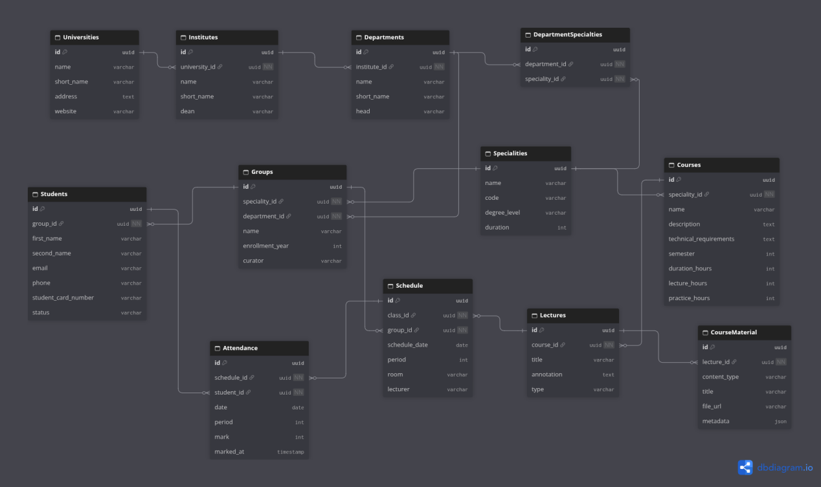

Схема размещения по хранилищам:
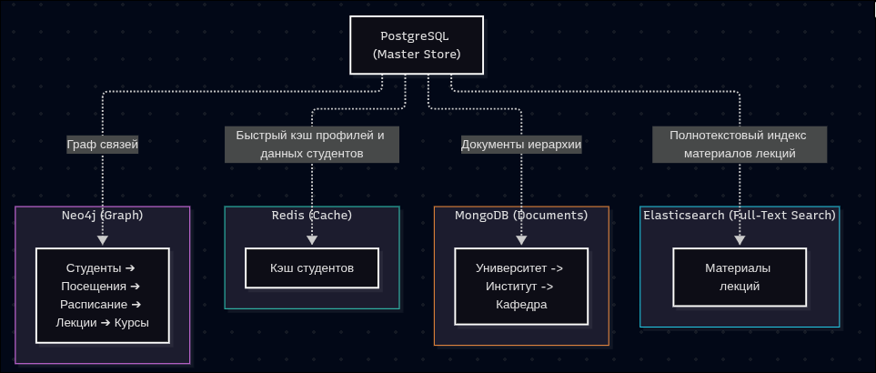
Диаграмма потоков данных:
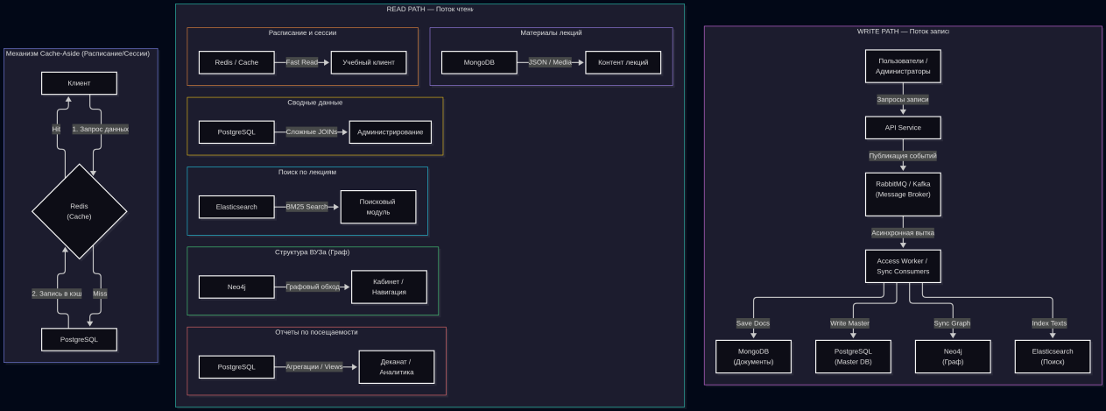
Генератор:
import os
import uuid
import random
import json
from datetime import datetime, timedelta
from dotenv import load_dotenv
from faker import Faker

# Импорты драйверов СУБД
import psycopg2
from psycopg2.extras import execute_values
from neo4j import GraphDatabase
import redis
from pymongo import MongoClient
from elasticsearch import Elasticsearch, helpers, ApiError

# Загрузка переменных из .env
env_path = os.path.join(os.path.dirname(__file__), '.env')
load_dotenv(env_path)

DB_HOST = os.getenv("DB_HOST", "localhost")

# PostgreSQL
PG_HOST = os.getenv("POSTGRES_HOST", DB_HOST)
PG_PORT = os.getenv("POSTGRES_PORT", "5432")
PG_USER = os.getenv("POSTGRES_USER", "admin")
PG_PASS = os.getenv("POSTGRES_PASSWORD", "superpassword123!")
PG_DB = os.getenv("POSTGRES_DB", "postgres")

# Neo4j
NEO4J_HOST = os.getenv("NEO4J_HOST", DB_HOST)
NEO4J_BOLT_PORT = os.getenv("NEO4J_BOLT_PORT", "7687")
neo4j_auth_raw = os.getenv("NEO4J_AUTH", "neo4j/superpassword123!").split('/')
NEO4J_USER = neo4j_auth_raw[0] if len(neo4j_auth_raw) > 0 else "neo4j"
NEO4J_PASS = neo4j_auth_raw[1] if len(neo4j_auth_raw) > 1 else "superpassword123!"

# Redis
REDIS_HOST = os.getenv("REDIS_HOST", DB_HOST)
REDIS_PORT = os.getenv("REDIS_PORT", "6379")
REDIS_PASS = os.getenv("REDIS_PASSWORD", "superpassword123!")

# MongoDB
MONGO_HOST = os.getenv("MONGO_HOST", DB_HOST)
MONGO_PORT = os.getenv("MONGO_PORT", "27017")
MONGO_USER = os.getenv("MONGO_INITDB_ROOT_USERNAME", "admin")
MONGO_PASS = os.getenv("MONGO_INITDB_ROOT_PASSWORD", "superpassword123!")
MONGO_DB = os.getenv("MONGO_INITDB_DATABASE", "db")

# Elasticsearch
ES_HOST_IP = os.getenv("ES_HOST", DB_HOST)
ES_PORT = os.getenv("ES_PORT", "9200")
ES_PASS = os.getenv("ELASTIC_PASSWORD", "superpassword123!")
ES_USER = "elastic"

fake = Faker('ru_RU')

# Объемы генерации
NUM_UNIVERSITIES = 2
INSTITUTES_PER_UNI = 2
DEPTS_PER_INST = 2
SPECS_PER_DEPT = 2
GROUPS_PER_SPEC = 2
STUDENTS_PER_GROUP = 5
COURSES_PER_SPEC = 2
LECTURES_PER_COURSE = 10
DAYS_OF_SCHEDULE = 5
CLASSES_PER_DAY = 3

UNI_PREFIXES = ["Национальный исследовательский", "Государственный", "Российский", "Московский", "Санкт-Петербургский"]
UNI_TYPES = ["университет", "институт", "академия"]
UNI_SPECS = ["информационных технологий", "кибернетики", "радиотехники", "электроники", "экономики и управления"]

DEPT_TOPICS = [
"Программирование и информатика", "Кибербезопасность", "Высшая математика",
"Прикладная физика", "Искусственный интеллект", "Базы данных и аналитика",
"Сетевые технологии", "Системный анализ", "Веб-технологии"
]

COURSE_NAMES = [
"Базы данных", "Алгоритмы и структуры данных", "Безопасность операционных систем",
"Машинное обучение", "Параллельные вычисления", "Разработка на Python",
"Архитектура ЭВМ", "Компьютерные сети", "Криптография", "Разработка под Web"
]

TECH_EQUIPMENT_OPTIONS = [
"Проектор, маркерная доска",
"Проектор, аудиосистема, микрофон преподавателя",
"Компьютерный класс с GPU-ускорителями, компьютерные рабочие места",
"Сетевое оборудование, проектор",
"VR оборудование",
"Оборудование для физических эксперементов"
]

def generate_random_data():
print("Генерация случайных данных...")

universities = []
institutes = []
departments = []
specialities = []
dept_specs = []
groups = []
students = []
courses = []
lectures = []
schedules = []
attendances = []

mongo_hierarchy_docs = []
neo_nodes = []
neo_relations = []

base_date = datetime(2026, 9, 1).date()
spec_counter = 1

for u_idx in range(NUM_UNIVERSITIES):
uni_id = str(uuid.uuid4())
uni_name = f"{random.choice(UNI_PREFIXES)} {random.choice(UNI_TYPES)} {random.choice(UNI_SPECS)}"
uni_short = "".join([word[0].upper() for word in uni_name.split() if len(word) > 2])[:6]
uni_address = fake.address()
uni_website = f"https://www.{uni_short.lower()}.edu.ru"

universities.append((uni_id, uni_name, uni_short, uni_address, uni_website))

uni_institutes_doc = []

for i_idx in range(INSTITUTES_PER_UNI):
inst_id = str(uuid.uuid4())
inst_name = f"Институт {random.choice(UNI_SPECS)}"
inst_short = f"И-{inst_name.split()[-1][:3].upper()}"
inst_dean = fake.name_male()

institutes.append((inst_id, uni_id, inst_name, inst_short, inst_dean))

inst_departments_doc = []

for d_idx in range(DEPTS_PER_INST):
dept_id = str(uuid.uuid4())
dept_name = f"Кафедра '{random.choice(DEPT_TOPICS)}'"
dept_short = f"КБ-{random.randint(1, 99)}"
dept_head = fake.name_male()

departments.append((dept_id, inst_id, dept_name, dept_short, dept_head))

inst_departments_doc.append({
"department_id": dept_id,
"name": dept_name,
"short_name": dept_short,
"head": dept_head
})

for s_idx in range(SPECS_PER_DEPT):
spec_id = str(uuid.uuid4())
code = f"09.03.{spec_counter:04d}"
spec_counter += 1
spec_name = f"Направление: {random.choice(DEPT_TOPICS)}"

specialities.append((spec_id, spec_name, code, "Бакалавриат", 4))
dept_specs.append((str(uuid.uuid4()), dept_id, spec_id))

group_ids = []
for g_idx in range(GROUPS_PER_SPEC):
group_id = str(uuid.uuid4())

# Год поступления от 2023 до 2026
enrollment_year = random.randint(2023, 2026)

group_name = f"{dept_short[:2]}-{random.randint(10, 99)}-{enrollment_year % 100}"
group_ids.append(group_id)

groups.append((group_id, spec_id, dept_id, group_name, enrollment_year, fake.name_male()))

for _ in range(STUDENTS_PER_GROUP):
st_id = str(uuid.uuid4())
is_male = random.choice([True, False])
f_name = fake.first_name_male() if is_male else fake.first_name_female()
l_name = fake.last_name_male() if is_male else fake.last_name_female()
card_num = str(fake.unique.random_number(digits=8, fix_len=True))

students.append((
st_id, group_id, f_name, l_name,
fake.unique.email(), fake.phone_number(), card_num, "active"
))

neo_nodes.append(("Student", {
"id": st_id, "first_name": f_name, "second_name": l_name, "card": card_num
}))

for c_idx in range(COURSES_PER_SPEC):
course_id = str(uuid.uuid4())
c_name = random.choice(COURSE_NAMES)
total_hours = random.choice([72, 108, 144])
lec_hours = total_hours // 2
prac_hours = total_hours // 2

tech_reqs = f"Технические средства: {random.choice(TECH_EQUIPMENT_OPTIONS)} ({fake.catch_phrase()})"

courses.append((
course_id, spec_id, c_name, fake.paragraph(nb_sentences=1),
tech_reqs, random.randint(1, 8), total_hours, lec_hours, prac_hours
))

neo_nodes.append(("Course", {"id": course_id, "name": c_name}))

course_lectures = []
for cl_idx in range(LECTURES_PER_COURSE):
lec_id = str(uuid.uuid4())
lec_item = {
"id": lec_id,
"course_id": course_id,
"title": f"{c_name}: {fake.sentence(nb_words=3)}",
"annotation": fake.paragraph(nb_sentences=2),
"content": fake.text(max_nb_chars=500),
"type": random.choice(["Lecture", "Practice", "Lab"])
}
lectures.append(lec_item)
course_lectures.append(lec_item)

neo_nodes.append(
("Lecture", {"id": lec_id, "title": lec_item["title"], "type": lec_item["type"]}))
neo_relations.append((course_id, lec_id, "HAS_LECTURE"))

if course_lectures and group_ids:
for day_offset in range(DAYS_OF_SCHEDULE):
sch_date = base_date + timedelta(days=day_offset)

for p in range(1, CLASSES_PER_DAY + 1):
selected_lec = random.choice(course_lectures)
selected_grp = random.choice(group_ids)
sch_id = str(uuid.uuid4())
teacher_name = fake.name_male()

schedules.append({
"id": sch_id,
"class_id": selected_lec["id"],
"group_id": selected_grp,
"date": sch_date,
"period": p,
"room": f"Аудитория {random.randint(100, 599)}",
"teacher": teacher_name
})

neo_nodes.append(("Schedule", {
"id": sch_id, "date": str(sch_date), "period": p,
"room": f"Аудитория {random.randint(100, 599)}"
}))
neo_relations.append((selected_lec["id"], sch_id, "SCHEDULED_AT"))

grp_students = [s for s in students if s[1] == selected_grp]
now_ts = datetime.now()
for st in grp_students:
att_id = str(uuid.uuid4())
mark_val = random.choice([0, 1])
attendances.append((
att_id, sch_id, st[0], sch_date, p, mark_val, now_ts
))

neo_nodes.append(
("Attendance", {"id": att_id, "mark": mark_val, "date": str(sch_date)}))
neo_relations.append((st[0], att_id, "HAS_ATTENDANCE"))
neo_relations.append((att_id, sch_id, "FOR_SCHEDULE"))

uni_institutes_doc.append({
"institute_id": inst_id,
"name": inst_name,
"short_name": inst_short,
"dean": inst_dean,
"departments": inst_departments_doc
})

mongo_hierarchy_docs.append({
"university_id": uni_id,
"name": uni_name,
"short_name": uni_short,
"address": uni_address,
"website": uni_website,
"institutes": uni_institutes_doc
})

return {
"universities": universities,
"institutes": institutes,
"departments": departments,
"specialities": specialities,
"dept_specs": dept_specs,
"groups": groups,
"students": students,
"courses": courses,
"lectures": lectures,
"schedules": schedules,
"attendances": attendances,
"mongo_hierarchy": mongo_hierarchy_docs,
"neo_nodes": neo_nodes,
"neo_relations": neo_relations
}

def init_pg_tables(pg_cur):
pg_cur.execute('CREATE EXTENSION IF NOT EXISTS "uuid-ossp";')

pg_cur.execute("""
CREATE TABLE IF NOT EXISTS universities (
id UUID PRIMARY KEY DEFAULT uuid_generate_v4(),
name VARCHAR(255) NOT NULL, short_name VARCHAR(50), address TEXT, website VARCHAR(255)
);
CREATE TABLE IF NOT EXISTS institutes (
id UUID PRIMARY KEY DEFAULT uuid_generate_v4(),
university_id UUID NOT NULL REFERENCES universities(id) ON DELETE CASCADE,
name VARCHAR(255) NOT NULL, short_name VARCHAR(50), dean VARCHAR(150)
);
CREATE TABLE IF NOT EXISTS departments (
id UUID PRIMARY KEY DEFAULT uuid_generate_v4(),
institute_id UUID NOT NULL REFERENCES institutes(id) ON DELETE CASCADE,
name VARCHAR(255) NOT NULL, short_name VARCHAR(50), head VARCHAR(150)
);
CREATE TABLE IF NOT EXISTS specialities (
id UUID PRIMARY KEY DEFAULT uuid_generate_v4(),
name VARCHAR(255) NOT NULL, code VARCHAR(50) NOT NULL UNIQUE, degree_level VARCHAR(50), duration INT
);
CREATE TABLE IF NOT EXISTS department_specialties (
id UUID PRIMARY KEY DEFAULT uuid_generate_v4(),
department_id UUID NOT NULL REFERENCES departments(id) ON DELETE CASCADE,
specialty_id UUID NOT NULL REFERENCES specialities(id) ON DELETE CASCADE,
CONSTRAINT idx_dept_spec UNIQUE (department_id, specialty_id)
);
CREATE TABLE IF NOT EXISTS groups (
id UUID PRIMARY KEY DEFAULT uuid_generate_v4(),
speciality_id UUID NOT NULL REFERENCES specialities(id) ON DELETE CASCADE,
department_id UUID REFERENCES departments(id) ON DELETE CASCADE,
name VARCHAR(100) NOT NULL, enrollment_year INT NOT NULL, curator VARCHAR(150)
);
CREATE TABLE IF NOT EXISTS students (
id UUID PRIMARY KEY DEFAULT uuid_generate_v4(),
group_id UUID NOT NULL REFERENCES groups(id) ON DELETE CASCADE,
first_name VARCHAR(100) NOT NULL, second_name VARCHAR(100) NOT NULL,
email VARCHAR(150) UNIQUE, phone VARCHAR(30), student_card_number VARCHAR(50) UNIQUE NOT NULL,
status VARCHAR(30) DEFAULT 'active'
);
CREATE TABLE IF NOT EXISTS courses (
id UUID PRIMARY KEY DEFAULT uuid_generate_v4(),
speciality_id UUID NOT NULL REFERENCES specialities(id) ON DELETE CASCADE,
name VARCHAR(255) NOT NULL, description TEXT, technical_requirements TEXT, semester INT NOT NULL,
duration_hours INT, lecture_hours INT, practics_hours INT
);
CREATE TABLE IF NOT EXISTS lectures (
id UUID PRIMARY KEY DEFAULT uuid_generate_v4(),
course_id UUID NOT NULL REFERENCES courses(id) ON DELETE CASCADE,
title VARCHAR(255) NOT NULL, annotation TEXT, type VARCHAR(50)
);
CREATE TABLE IF NOT EXISTS schedule (
id UUID PRIMARY KEY DEFAULT uuid_generate_v4(),
class_id UUID NOT NULL REFERENCES lectures(id) ON DELETE CASCADE,
group_id UUID NOT NULL REFERENCES groups(id) ON DELETE CASCADE,
schedule_date DATE NOT NULL, period INT NOT NULL, room VARCHAR(50), teacher VARCHAR(150)
);

-- Партиции ATTENDANCE
CREATE TABLE IF NOT EXISTS attendance (
id UUID NOT NULL DEFAULT uuid_generate_v4(),
schedule_id UUID NOT NULL REFERENCES schedule(id) ON DELETE CASCADE,
student_id UUID NOT NULL REFERENCES students(id) ON DELETE CASCADE,
date DATE NOT NULL,
period INT NOT NULL,
mark INT NOT NULL,
marked_at TIMESTAMP DEFAULT CURRENT_TIMESTAMP,
PRIMARY KEY (id, date)
) PARTITION BY RANGE (date);

CREATE INDEX IF NOT EXISTS idx_students_group ON students(group_id);
CREATE INDEX IF NOT EXISTS idx_schedule_group_date ON schedule(group_id, schedule_date);
CREATE INDEX IF NOT EXISTS idx_attendance_student ON attendance(student_id);
""")

def create_attendance_partitions(pg_cur, start_year=2026, start_month=9, months_count=4):
for i in range(months_count):
m = (start_month - 1 + i) % 12 + 1
y = start_year + (start_month - 1 + i) // 12

next_m = m % 12 + 1
next_y = y if m < 12 else y + 1

partition_name = f"attendance_y{y}m{m:02d}"
from_date = f"{y}-{m:02d}-01"
to_date = f"{next_y}-{next_m:02d}-01"

pg_cur.execute(f"""
CREATE TABLE IF NOT EXISTS {partition_name} PARTITION OF attendance
FOR VALUES FROM ('{from_date}') TO ('{to_date}');
""")
print("Партиции таблицы attendance успешно созданы!")

def init_es_index(es_client):
index_name = "lectures"
try:
exists = es_client.indices.exists(index=index_name)
except ApiError:
exists = False

if not exists:
settings = {
"analysis": {
"analyzer": {
"russian_analyzer": {
"tokenizer": "standard",
"filter": ["lowercase", "russian_stop", "russian_stemmer"]
}
},
"filter": {
"russian_stop": {"type": "stop", "stopwords": "_russian_"},
"russian_stemmer": {"type": "stemmer", "language": "russian"}
}
}
}
mappings = {
"properties": {
"lecture_id": {"type": "keyword"},
"course_id": {"type": "keyword"},
"title": {"type": "text", "analyzer": "russian_analyzer", "fields": {"keyword": {"type": "keyword"}}},
"annotation": {"type": "text", "analyzer": "russian_analyzer"},
"content_text": {"type": "text", "analyzer": "russian_analyzer"},
"type": {"type": "keyword"},
"created_at": {"type": "date"}
}
}
es_client.indices.create(index=index_name, settings=settings, mappings=mappings)

def run_seeder():
data = generate_random_data()

print(f"Сгенерировано:")
print(f" - universities: {len(data['universities'])}")
print(f" - students: {len(data['students'])}")
print(f" - lectures: {len(data['lectures'])}")
print(f" - schedules: {len(data['schedules'])}")
print(f" - attendances: {len(data['attendances'])}")

# 1. PostgreSQL
print("\nЗаполнение PostgreSQL")
with psycopg2.connect(host=PG_HOST, port=PG_PORT, user=PG_USER, password=PG_PASS, dbname=PG_DB) as pg_conn:
with pg_conn.cursor() as pg_cur:
pg_cur.execute("""
DROP TABLE IF EXISTS attendance, schedule, lectures, classes, courses,
students, groups, department_specialties, specialities, departments,
institutes, universities CASCADE;
""")
init_pg_tables(pg_cur)
create_attendance_partitions(pg_cur, start_year=2026, start_month=9, months_count=4)

execute_values(pg_cur,
"INSERT INTO universities (id, name, short_name, address, website) VALUES %s ON CONFLICT DO NOTHING",
data["universities"])
execute_values(pg_cur,
"INSERT INTO institutes (id, university_id, name, short_name, dean) VALUES %s ON CONFLICT DO NOTHING",
data["institutes"])
execute_values(pg_cur,
"INSERT INTO departments (id, institute_id, name, short_name, head) VALUES %s ON CONFLICT DO NOTHING",
data["departments"])
execute_values(pg_cur,
"INSERT INTO specialities (id, name, code, degree_level, duration) VALUES %s ON CONFLICT (code) DO NOTHING",
data["specialities"])
execute_values(pg_cur,
"INSERT INTO department_specialties (id, department_id, specialty_id) VALUES %s ON CONFLICT DO NOTHING",
data["dept_specs"])
execute_values(pg_cur,
"INSERT INTO groups (id, speciality_id, department_id, name, enrollment_year, curator) VALUES %s ON CONFLICT DO NOTHING",
data["groups"])
execute_values(pg_cur,
"INSERT INTO students (id, group_id, first_name, second_name, email, phone, student_card_number, status) VALUES %s ON CONFLICT DO NOTHING",
data["students"])
execute_values(pg_cur,
"INSERT INTO courses (id, speciality_id, name, description, technical_requirements, semester, duration_hours, lecture_hours, practics_hours) VALUES %s ON CONFLICT DO NOTHING",
data["courses"])

lectures_tuples = [(l["id"], l["course_id"], l["title"], l["annotation"], l["type"]) for l in
data["lectures"]]
execute_values(pg_cur,
"INSERT INTO lectures (id, course_id, title, annotation, type) VALUES %s ON CONFLICT DO NOTHING",
lectures_tuples)

sched_tuples = [(s["id"], s["class_id"], s["group_id"], s["date"], s["period"], s["room"], s["teacher"]) for
s in data["schedules"]]
execute_values(pg_cur,
"INSERT INTO schedule (id, class_id, group_id, schedule_date, period, room, teacher) VALUES %s ON CONFLICT DO NOTHING",
sched_tuples)

execute_values(pg_cur,
"INSERT INTO attendance (id, schedule_id, student_id, date, period, mark, marked_at) VALUES %s ON CONFLICT DO NOTHING",
data["attendances"])
print("PostgreSQL готова!")

# 2. Neo4j
print("\nЗаполнение Neo4j")
with GraphDatabase.driver(f"bolt://{NEO4J_HOST}:{NEO4J_BOLT_PORT}", auth=(NEO4J_USER, NEO4J_PASS)) as neo4j_driver:
with neo4j_driver.session() as session:
session.run("MATCH (n) DETACH DELETE n;")

nodes_by_label = {}
for label, props in data["neo_nodes"]:
nodes_by_label.setdefault(label, {})[props["id"]] = props

for label, props_dict in nodes_by_label.items():
session.run(
f"UNWIND $batch AS row MERGE (n:{label} {{id: row.id}}) SET n += row",
batch=list(props_dict.values())
)

rels_by_type = {}
for src_id, dst_id, rel_type in data["neo_relations"]:
rels_by_type.setdefault(rel_type, []).append({"src": src_id, "dst": dst_id})

for rel_type, rel_list in rels_by_type.items():
session.run(
f"UNWIND $batch AS row MATCH (a {{id: row.src}}), (b {{id: row.dst}}) MERGE (a)-[:{rel_type}]->(b)",
batch=rel_list
)
print("Neo4j готова!")

# 3. Redis (Очистка кэша)
print("\nЗаполнение Redis")
r_client = redis.Redis(host=REDIS_HOST, port=int(REDIS_PORT), password=REDIS_PASS, decode_responses=True)
r_client.flushall()
print("Кэш Redis очищен!")
r_client.close()

# 4. MongoDB (Исключительно коллекция university_hierarchy)
print("\nЗаполнение MongoDB")
mongo_uri = f"mongodb://{MONGO_USER}:{MONGO_PASS}@{MONGO_HOST}:{MONGO_PORT}/?authSource=admin"
with MongoClient(mongo_uri) as mongo_client:
mongo_db = mongo_client[MONGO_DB]
mongo_db.drop_collection("course_materials")
mongo_collection = mongo_db["university_hierarchy"]
mongo_collection.delete_many({})

if data["mongo_hierarchy"]:
res = mongo_collection.insert_many(data["mongo_hierarchy"])
print("MongoDB готова!")

# 5. Elasticsearch
print("\nЗаполнение Elasticsearch")
with Elasticsearch([f"http://{ES_HOST_IP}:{ES_PORT}"], basic_auth=(ES_USER, ES_PASS)) as es_client:
init_es_index(es_client)

es_actions = []
for lec in data["lectures"]:
es_actions.append({
"_index": "lectures",
"_id": lec["id"],
"_source": {
"lecture_id": lec["id"],
"course_id": lec["course_id"],
"title": lec["title"],
"annotation": lec["annotation"],
"content_text": lec["content"],
"type": lec["type"],
"created_at": datetime.now().isoformat()
}
})
if es_actions:
helpers.bulk(es_client, es_actions)
print("Elasticsearch готова!")

if __name__ == "__main__":
run_seeder()

